trygonus.com

Trygonus Report 2​

The Official and Unofficial Purposes of President Trump’s Executive Order on “Reciprocal Trade and Tariffs”



At the swearing in of Tulsi Gabbard as U.S. Director of National Intelligence on 12th February 2025, President Trump answered a question confirming his administration’s intention to achieve tariff reciprocity with U.S. trading partners through an Executive order to be issued imminently:

*…I may do it today… or I may do it tomorrow morning, but we’ll be signing reciprocal tariffs. The world has taken advantage of the United States for many years, they’ve charged us massive tariffs that we haven't charged them, and as you know I just did something on steel and aluminum – 25% – and that will go up at some point, but… 25%, which… will level the playing field quite a bit. I did it previously – 50% – and Obama… was very weak and Biden was even weaker on steel… it really started with Obama, the world really took advantage of us, and then that morphed into… Biden… [being] so worried about trying to attack his political opponent that he didn’t know what he was doing with respect to countries taking advantage. He should have looked at the countries – both friend and foe – taking advantage of us, so… we’re going to be doing reciprocal tariffs which is whatever they charge, we charge, very simply…[i]*

President Trump proceeded to sign his Executive Order on ‘Reciprocal Trade and Tariffs’ the following day (13th February 2025), which is explained in a Memorandum to the Secretaries of the Treasury, Commerce, and Homeland Security, as well as the Director of the Office of Management and Budget, the U.S. Trade Representative, the Assistant to the President for Economic Policy and the Senior Counselor to the President for Trade and Manufacturing. The White House Memorandum asserts in its ‘background’ preamble that the U.S. “has one of the most open economies” with “among the lowest weighted tariff rates in the world”, imposing “fewer barriers to imports than other major world economies, including those with similar political and economic systems”, and that the U.S. “has been treated unfairly by trading partners, both friend and foe”, as the underlying reason for its comprehensive and targeted approach to achieving reciprocity in the terms of trade, with or without tariffs, to achieve that result.[ii] The approach outlined identifies not only a) “tariffs imposed on United States products”, but also b) “unfair, discriminatory, or extraterritorial taxes imposed by our trading partners… including a value-added tax” or VAT, c) “costs… arising from nontariff barriers or measures… including subsidies and burdensome regulatory requirements on” U.S. businesses, d) non-market-based currency exchange rates, “wage suppression” or other anticompetitive “mercantilist policies”, and e) “any other practice” that “the United States Trade Representative, in consultation with the Secretary of the Treasury, the Secretary of Commerce, and the Senior Counselor to the President for Trade and Manufacturing” judge to impose “any unfair limitation on market access or any structural impediment to fair competition” for the U.S. “market economy”. [iii]

Trygonus 2

Occurring in the context of initially apparently jocular but since oft-repeated and seemingly serious comments from then President-elect Trump at a Mar-a-Lago meeting with Prime Minister Trudeau that Canada could become the 51st American state, it is possible that President Trump is really concerned with Canada’s contribution to border security. Evidently, President Trump does not see trade or economics in isolation from domestic public opinion or from his own instinctive formulations of geopolitical realpolitik. Canada remains one of the eight remaining NATO members to fail to achieve its commitment to spend 2% on defence, despite strong pressure from President Trump on this apparent ‘free-rider’ problem during his first term and the likelihood that Canada will seek to be included through the North American Aerospace Defense Command or NORAD in any U.S. plans to develop its own continental version of Israel’s ‘Iron Dome’. However, what appears to exercise the President’s attention most is that Canada is a significant net exporter into the U.S. market. Energy exports of oil and gas account for a large part of these, on which President Trump imposed a lower tariff of 10%.[iv] However, cars exports from Canada into the U.S. to compete with those made in American ‘rustbelt’ swing states are in President Trump’s crosshairs. During his recent campaign, then candidate Trump credited his threats of extremely high tariffs on Chinese cars being manufactured in Mexico with an end to construction of what would, he claims, have been the largest car plant in the world. The idea of China moving manufacturing to other countries to target the U.S. market particularly arouses his ire.

When intertwined with his perception of unfair trade practices, President Trump’s fervency on combating trade imbalances and other items (especially defence expenditure) in the tally sheet of America’s relationships with friends and allies is a longstanding preoccupation. Shortly after the release of his 1987 book The Art of the Deal, Trump spent ‘almost [U.S.]$100,000 to release an “open letter” in full-page ads in three major US newspapers’ titled ‘There's nothing wrong with America’s Foreign Defense Policy that a little backbone can't cure.’[v] This was then brought up by Opera Winfrey in a 1988 interview in which she asked Donald Trump if it signaled an ambition to run for the presidency while asking what he would do differently, to which his reply is particularly telling:

*I’d make our allies – forgetting about the enemies, the enemies you can’t talk to so easily – I’d make our allies pay their fair share. We’re a debtor nation. Something is going to happen with this country over the next number of years, because you can’t keep going on losing 200 billion, and yet we, we let Japan come in and dump everything right into our markets… it’s not free trade. If you ever go to Japan right now and try to sell something forget about it Oprah, just forget about it, its almost impossible. They don’t have laws against it, they just make it impossible. They come over here, they sell their cars, their VCRs, they knock the hell out of our companies, and hey, I have tremendous respect for the Japanese people, I mean you can respect somebody that’s beatin’ the hell out of you, but they are beating the hell out of this country. Kuwait – they live like kings – the poorest person in Kuwait, they live like kings, and yet they’re not paying. We make it possible for them to sell their oil – why aren’t they paying us 25% of what they’re making, it’s a joke. [vi]*

Trygonus 3

The impetus and rationale of President Trump’s belief in tariffs as a blunt bargaining tool to effectively extort such payment, one way or another, or to improve the terms of trade for American companies, is quite evident in this answer from thirty-seven years ago. From this early political intervention, through his first presidential term, and to the present, Donald Trump has remained remarkably consistent in his assessment of the problems he believes need fixing in America’s trading relationships. During his latest presidential campaign he extoled the beauty of tariffs to massive audiences at rallies and one on one with podcasters, such as Joe Rogan, to whom he declared the word ‘tariff’ to be “the most beautiful word… more beautiful than love… This country can become rich with the use – the proper use – of tariffs.”[vii] Associate Professor of History at Dartmouth College, Jennifer Miller, told the BBC’s New York correspondent Nada Tawfik that “I think that's one reason he likes tariffs so much, is they fit not only with his transactional ideology but his sense of himself, which is very deeply rooted as this successful dealmaker.”[viii]

Speaking to the press in the Oval Office just before signing his Executive Order on ‘Reciprocal Trade and Tariffs’ President Trump summarised:

*Well I want to say that actually tariffs are good. Tariffs are great actually, and the problem is we didn’t charge them, and everyone else did. They charged us, but we didn’t charge them, because we were generous, or foolish, or stupid, or all of the above. So this is one of the biggest… economic bills ever signed… I think it’s probably the biggest in terms of what it represents. Now this doesn’t include what we did a few days ago with steel and aluminum – that’s over and above this, cars will be over and above this – look at what’s coming shortly. If you take a look at the [semiconductor] chips… [and] pharmaceuticals will be over and above… Otherwise this is covering pretty much everything, and it’s gonna be great for the United States, and fair for the world. I mean, it’s the most fair you can do. We could charge a flat tariff, and that would be, in many ways easier, but you could make a case that that wouldn’t be fair to other countries. This is fair – remember… whatever they charge us, we charge them, and [if] they charge us nothing, we charge them nothing, and it really works out well, and we’d be very happy to have nothing and nothing. We wouldn’t have any tariffs at all. But to me it’s… something that I’m very proudly doing, it should have been done many, many years ago, and we’re doing it now…[ix]*

Following the signing of his Executive Order on ‘Reciprocal Trade and Tariffs’, President Trump was asked about his meeting with Indian Prime Minister Narendra Modi to be held later the same day, and what relationship he would like to have with India, to which he responded:



Trygonus 4

*India traditionally is the highest, just about the highest tariffed country… we will be talking about that… there are a couple of smaller countries that are actually [charging] more, but India… charge tremendous tariffs. I remember when Harley-Davidson couldn’t sell their motorbikes into India because of the fact that… the tax was so high, the tariff was so high, and Harley was forced to… build… I think they built a factory in India in order to avoid paying the tariffs, and that is what people can do with us. They can build a factory here [in the U.S.], a plant or whatever it may be, here, and that includes the medical, that includes cars, that includes chips, and semiconductors, that includes everything. If you build here you have no tariffs whatsoever, and I think that’s what’s gonna happen. I think our country is going to be flooded with jobs.[x]*

Persuading foreign companies which desire to preserve their access to the U.S. market to open factories in the U.S. goes beyond import-substitution by domestic manufacturers or other existing players. His answer here also clearly identifies the industries President Trump will be particularly targeting for development, onshoring or repatriation, alongside his desire to protect American steel and aluminum manufacturers. President Trump dismissed the idea that he would be granting exemptions (which could provide a particularly powerful form of patronage for his administration), and also pushed back on the conventional economic wisdom that tariffs would inevitably cause inflation in prices for consumers:

*Not necessarily, not necessarily, but I will tell you what will go up is jobs. The jobs will go up tremendously. We are going to have great jobs, jobs for everybody. This is something that should have been done many years ago. China did it. I mean China at a level that probably nobody has ever seen before. If you manufactured a car you couldn’t send it into China. The tariff was so high. So everybody went and they built in China, it was no big secret. [xi]*

President Trump also specifically identified the “20%” VAT or value-added tax (a tax on goods and services that is more complex than a typical sales tax) applied by “certain areas of Europe” as a key target of the reciprocal tariff regime, arguing that “the VAT system… is far more punitive than a tariff, similar but more punitive… the way we are going to look at, we are going to call it a tariff because they use that as a way of getting away from… the designation of tariff, but it’s essentially similar or the same thing. So a VAT tax will be viewed as a tariff.”[xii] European Union or EU rules actually only require a standard rate of at least 15% for VAT while strictly restricting which items can be exempted by member states. President Trump’s analysis here likely derives from the work of Peter Navarro, who was Director of the U.S. Office of Trade and Manufacturing Policy and of the White House National Trade Council and was widely perceived as the principle architect of the U.S.’s increasing protectionism and tariff war with China during President Trump’s first term. Peter Navarro was subsequently sanctioned by China and then imprisoned for four months towards the end of President Biden’s administration for refusing to comply with congressional subpoenas. Having now returned to the White House as a Senior Counselor to the President for Trade and Manufacturing, Peter Navarro was called upon to state that:

Trygonus 5

*Tariffs are bad. Around the world they are higher than we have, but I will tell you what – the non-monetary barriers that are imposed on us are even worse, and President Trump has been right to single out, for example… VAT tax, the value-added tax. There is a reason why Germany sells eight more cars to every one we sell them, and it’s not American craftsmanship, and it’s not American design, its simply the unfair trade practices, and that VAT is a killer, it’s a hidden tariff, it’s also, as Secretary [Howard] Lutnick [President Trump’s nominee for U.S. Secretary of Commerce] said, it’s a hidden export subsidy. There is about a 20,000 dollar differential between when we try to sell them a car and they sell us a car, and that is going to stop with this man… [ President Trump].[xiii]*

Like President Trump’s tariffs, VAT is regressive and its initial implementation as well as any rises in the tax would be seen as inflationary. VAT might be compared with U.S. sales taxes, which vary by state and within states, from between 7.25% and 10.25% in different areas of California for example, where they are particularly high. However, VAT is more complicated than these kinds of sales tax, and is defined in the White House Memorandum as “a type of consumption tax that is levied on the incremental increase in value of a good or service at each stage of the supply chain.”[xiv] There had been some discussion of the UK avoiding being included in tariffs aimed at the EU, in part because the UK has left the block and also because, unlike many of the U.S.’s other major trading partners, the UK is not a net exporter into the U.S. market and a large share of its exports to the U.S. are in services. However, the fact that the UK has not chosen to alter its VAT regime dramatically following Brexit, means that this will now become the most urgent and serious topic of bilateral negotiation between the U.S. and the UK, whether or not the Labour government of Prime Minister Sir Kier Starmer seeks to resume dialogue towards a UK-U.S. trade deal. Melissa Lawford reports analysts warning of the “risk of a £24bn blow to the [British] economy should” its longstanding VAT system be targeted for reciprocal tariffs in this way.[xv] Having left the EU, the UK is now free to replace the regressive tax with more direct and progressive taxes which might prove popular and could be presented as in keeping with the stated values of the Labour Party who enjoy a strong majority in parliament under Sir Kier Starmer, however, the Prime Minister will be anxious not to be seen to be making such a major reform under duress as a concession to the Trump administration.

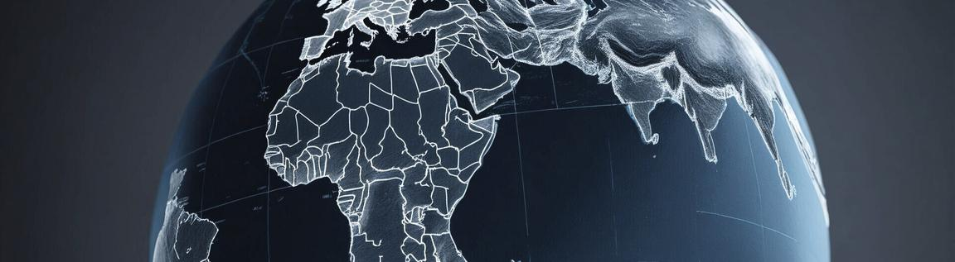

Trygonus 6



While President Trump’s aggressive tariff diplomacy has already caused several friendly countries – including Canada and Mexico – to give in to his demands, whether or not these are directly related to trade, or in the case of India, to make major concessions on trade that they hope will conciliate him, the real question is how a major economic rival like China will respond in the short, medium and long term, to the prospect of a renewed trade war. Furthermore, as the moving and eloquent speech by Canadian Prime Minister Justin Trudeau on 1st February 2025 reacting to President Trump’s imposition of 25% tariffs made clear,[xvi] political and economic victories, won at the expense of friendly or allied nations, do not come cost-free. If the U.S. is perceived to be bullying economically weaker states, and especially its closest neighbours, this is likely to do lasting damage to their diplomatic relationships with and public perceptions of the United States. Writing for the Financial Times or FT, British journalist Gideon Rachman went so far as to argue that this approach threatens to play into the hands of America’s strategic adversaries by threatening “to destroy the unity of the western alliance” and potentially, as “informal” co-operation strengthens during any prolonged “tariff wars”, “sowing the seeds of an alternative grouping formed by the many countries that feel newly threatened by America.”[xvii]



Trygonus 7

**References**

1. Associated Press, ‘Trump speaks after Tulsi Gabbard sworn in’, Youtube Livestream (12.2.2025), 10:30-12:00, accessible at [https://m.youtube.com/watch? v=jK3vRjUTg5c&pp=ygUnVHJ1bXAgZ2l2ZXMgcmVtYXJrcyBhZnRlciB0dWxzaSB nYWJiYXJk](https://m.youtube.com/watch?v=jK3vRjUTg5c&pp=ygUnVHJ1bXAgZ2l2ZXMgcmVtYXJrcyBhZnRlciB0dWxzaSBnYWJiYXJk)
2. The White House, ‘Reciprocal Trade and Tariffs: Memorandum for the Secretary of the Treasury, The Secretary of Commerce, The Secretary of Homeland Security, The Director of the Office of Management and Budget, The United States Trade Representative, The Assistant to the President for Economic Policy, The Senior Counselor to the President for Trade and Manufacturing’ (13.2.2025), available at <https://www.whitehouse.gov/articles/2025/02/reciprocal-trade-and-tariffs/>
3. Ibid.
4. The White House, ‘Fact Sheet: President Donald J. Trump Imposes Tariffs on Imports from Canada, Mexico and China’ (1.2.2025), available at <https://www.whitehouse.gov/fact-sheets/2025/02/fact-sheet-president-donald-j-trump-imposes-tariffs-on-imports-from-canada-mexico-and-china/>
5. Nada Tawfik, ‘How Japan sparked Trump's 40-year love affair with tariffs’, BBC (8.2.2025), available at <https://www.bbc.com/news/articles/c4gp5pw654lo>
6. ‘Donald Trump Teases a Presidential Bid During a 1988 Oprah Show Appearance’, (Aired on 25.4.1988), available at <https://www.oprah.com/own-oprahshow/what-donald-trump-told-oprah-about-his-presidential-hopes-video>
7. Cited in Hadriana Lowenkron, ‘Trump Talks Xi, Tariffs and Aliens in Freewheeling Rogan Podcast’, 26 October 2024 at 12:34AM EDT, available at <https://www.bnnbloomberg.ca/business/international/2024/10/26/trump-talks-xi-tariffs-and-aliens-in-freewheeling-rogan-podcast/>
8. Cited in Tawfik, ‘How Japan sparked Trump's 40-year love affair with tariffs’
9. FOX 5 Washington DC, ‘President Donald Trump signs Executive Orders; talks reciprocal tariffs’, Youtube (14.12.2025), 15:15-16:55, available at <https://www.youtube.com/watch?v=krkZtxaVIe4>
10. Ibid., 17:47-19:02
11. Ibid., 19:06-19:37
12. Ibid., 4:47-5:31
13. Ibid., 14:27-15:15
14. The White House, ‘Reciprocal Trade and Tariffs’
15. Melissa Lawford, ‘Britain at risk of £24bn Trump tariff raid over VAT’, Daily

Telegraph (11.2.2025, 4:20pm GMT), available at <https://www.telegraph.co.uk/business/2025/02/11/britain-at-risk-of-trump-tariff-raid-over-vat/>

1. CBC News, ‘Read Justin Trudeau's speech in response to Trump's tariffs’,

Feb 02, 2025 2:58 PM EST, available at <https://www.cbc.ca/news/politics/trudeau-speech-trump-tariffs-1.7448540>

1. Gideon Rachman, ‘Trump is sowing the seeds of an anti-American

alliance’, Financial Times (3.2.2025), available at <https://www.ft.com/content/ba1c81a2-0b5e-4a40-a9f6-35228d958b19>

Trygonus 8

**About Trygonus**

At Trygonus, we are dedicated to providing unparalleled research, analysis, and consultancy services focused on the ever-evolving geopolitical and regulatory landscapes. Our mission is to empower businesses and investors by delivering insights that drive strategic decision-making and foster sustainable growth. With a strong emphasis on the financial and regulatory sectors in Asia, we are uniquely positioned to help our clients navigate challenges and seize opportunities in a globalized world. Our team of experts works tirelessly to ensure that our clients are well-equipped to handle trade tariffs, export restrictions, and other critical issues, while building strategic relationships with policymakers and stakeholders.

**Our Expertise**

Lobbying and Advocacy

Our team excels in crafting and executing lobbying strategies that influence policy decisions and foster favorable regulatory environments for our clients.

Government Relations

We build and maintain strong relationships with government officials and stakeholders, ensuring our clients’ interests are represented effectively at all levels of government.

Strategic Communications

Our communications experts develop compelling narratives and messaging that resonate with key audiences, enhancing our clients’ public profiles and policy objectives.

Risk Assessment

We provide in-depth analysis and insights into geopolitical and regulatory risks, helping clients navigate complex environments with confidence.

Market Intelligence

Our research team delivers timely and relevant market intelligence, enabling clients to make informed strategic decisions.

Policy Analysis

We offer comprehensive policy analysis to help clients understand and anticipate changes in the regulatory landscape.

Trygonus 9

**Our Team**



**DR. UTHER CHARLTON-STEVENS**

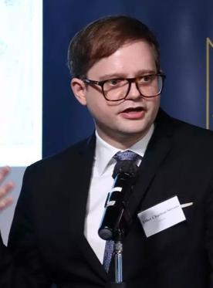

Founder and CEO

uther@charltonstevens.com

Dr Uther Charlton-Stevens is the Founder and CEO of Trygonus. A Fellow of the Royal Asiatic Society, Dr Charlton-Stevens is a South Asia specialist and a historian of empire and conflict, with multiple well-reviewed scholarly publications, and extensive public speaking experience. His first book covers Indian constitutional politics as it relates to treatment of racial, ethnic and religious minority communities. Dr Charlton-Stevens has lived in China, Russia, and the UK, and speaks Mandarin Chinese, Russian and Spanish. He earned his bachelors and doctoral degrees from the University of Oxford and a master of science with distinction from the London School of Economics and Political Science. Having lectured at several universities, most recently the University of Hong Kong, he is also the Treasurer and Director of the Commonwealth Chamber of Commerce in Hong Kong. Dr Charlton-Stevens is keenly interested in political and geopolitical developments and strategic thinking across multiple parts of the world, particularly India, China, Russia, the UK and the United States of America.

Trygonus 10

**Our Team**



**ISABELLA CHARLTON**



Director for the Americas

isabella.cs@gmail.com

Isabella Charlton is Director for the Americas at Trygonus, handling government relations, corporate networking, lobbying and advocacy. A UK-qualified lawyer and fluent Mandarin-speaker, she grew up in Hong Kong and lived in Beijing before moving to the United States and naturalising as an American. Over the years, Isabella has established a high-level network of influential contacts in government, the judiciary, the corporate and regulatory space, and with tech startups and CEOs. Having served as master of ceremonies for high profile events, Isabella’s talent for public speaking and connecting with people as individuals and as audiences, have been sharpened through her experience appearing on podcasts and performing standup comedy at prominent venues around the world from California to Australia, including a show at the Edinburgh Festival Fringe – she has even performed Xiangsheng crosstalk comedy in Mandarin Chinese, as well as appearing in television and film in China. Isabella holds degrees in law from the University of Oxford and the London School of Economics and Political Science.

Trygonus 11

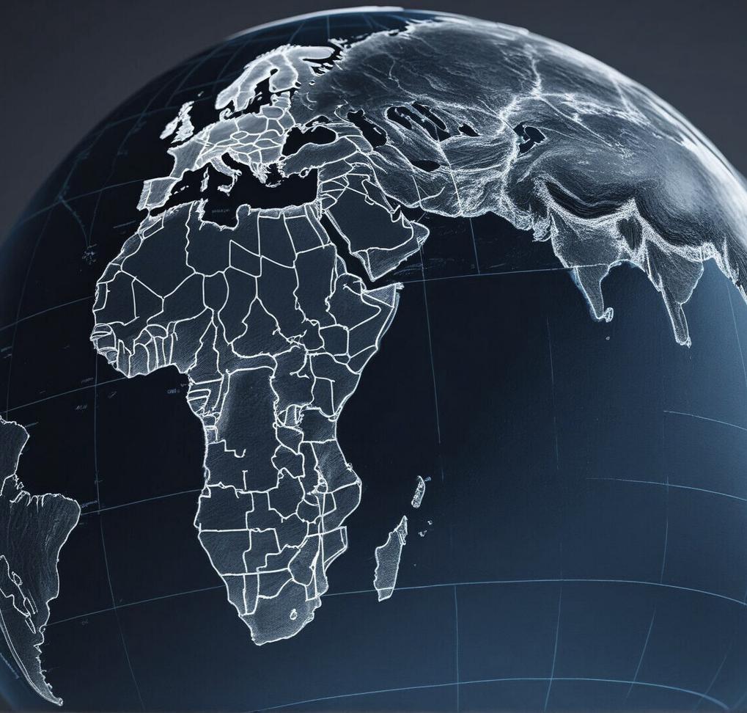

Connect with Trygonus Today



trygonus.com